Jenkins Assignment 4 using pipeline
Create 1 repository on github and create 3 branch in that repo with adding index.html file in each repository now build and run using pipeline job and check.

Step 1 – lauch instance install java21 then create 1 directory inside mnt and add 1 folder and wget tomcat then setup Jenkins.
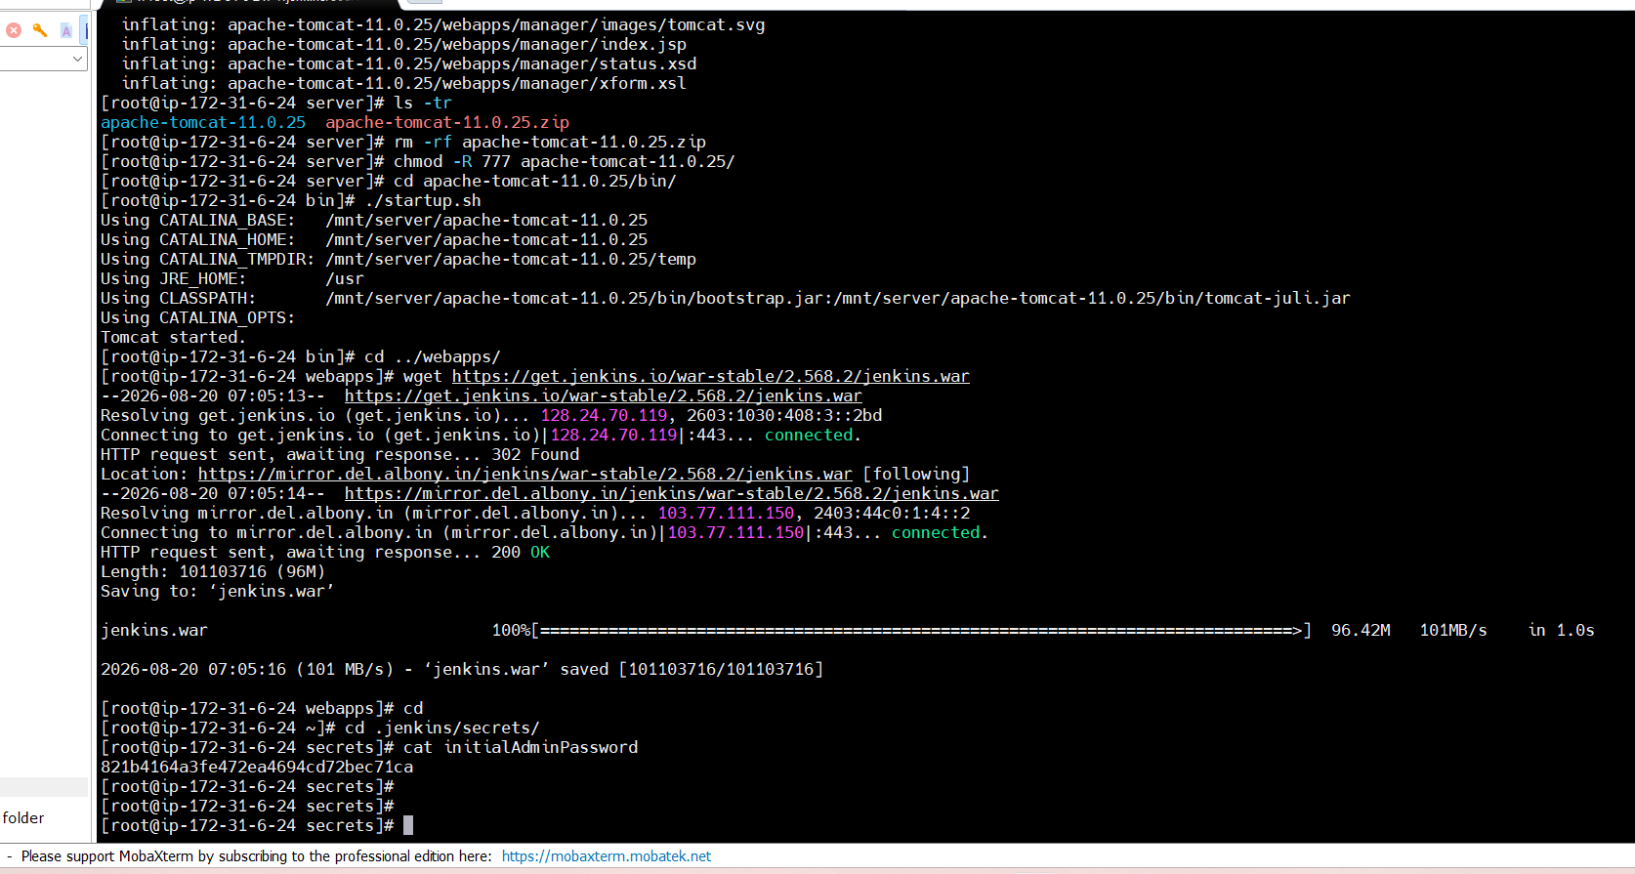
Step 2 – goto github and create 1 repository then in your linux terminal create 1 folder inside mnt with that same repo name and do git init then add this origin
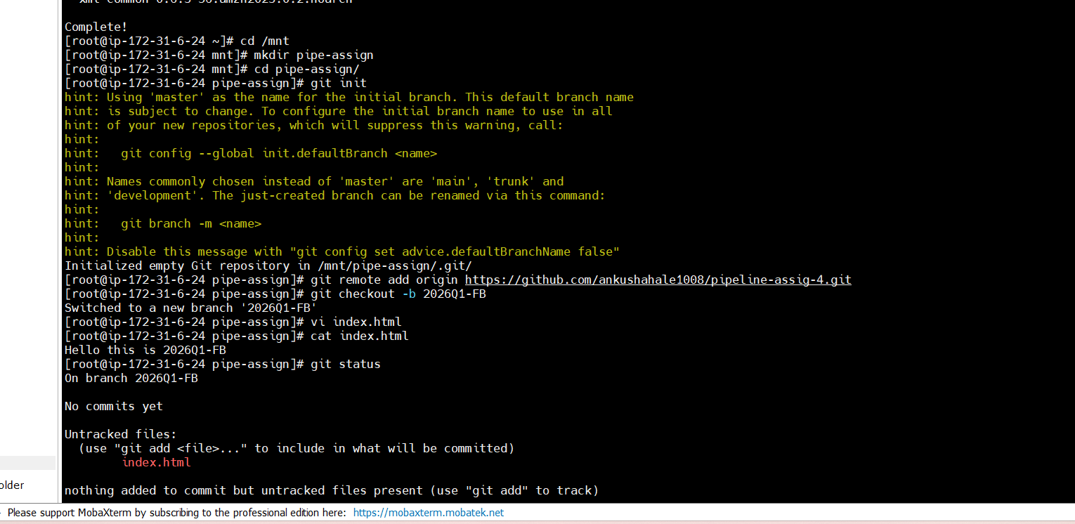
Step 3 – then create 3 branch and add index.html in each branch and push to github
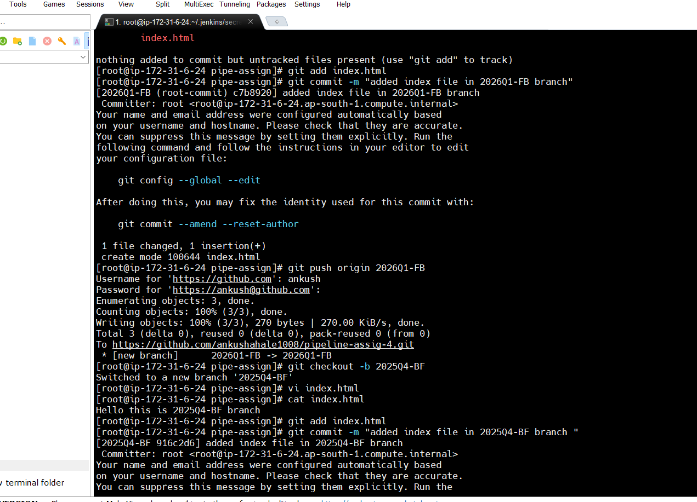
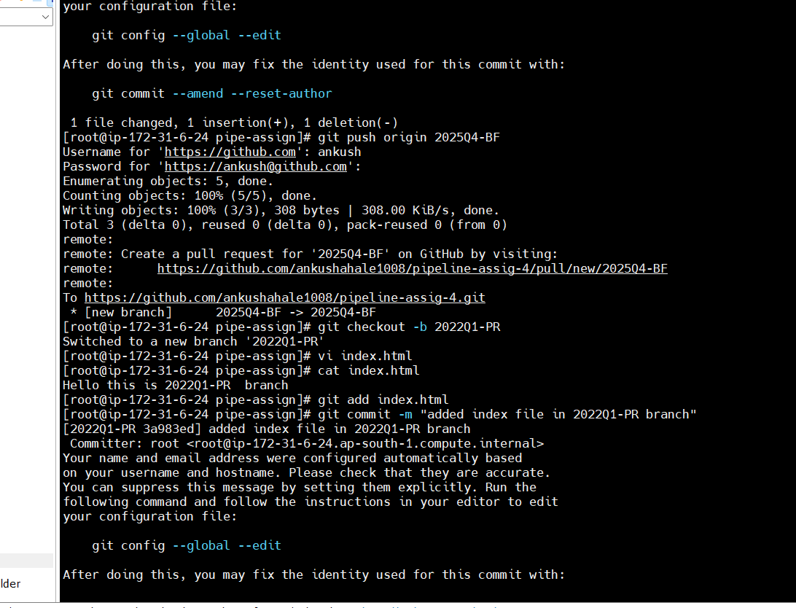
Step 4 – pur github setup is ready now goto Jenkins dashboard and create job using pipeline
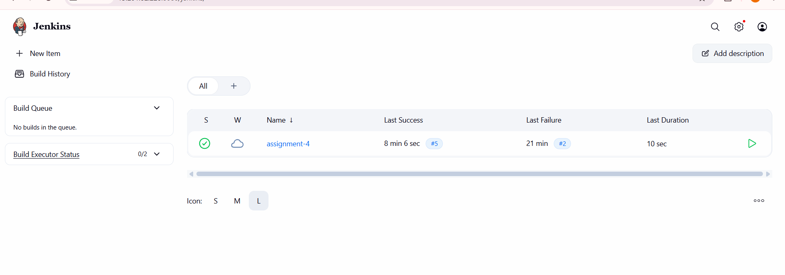
Step 5 – write pipeline script
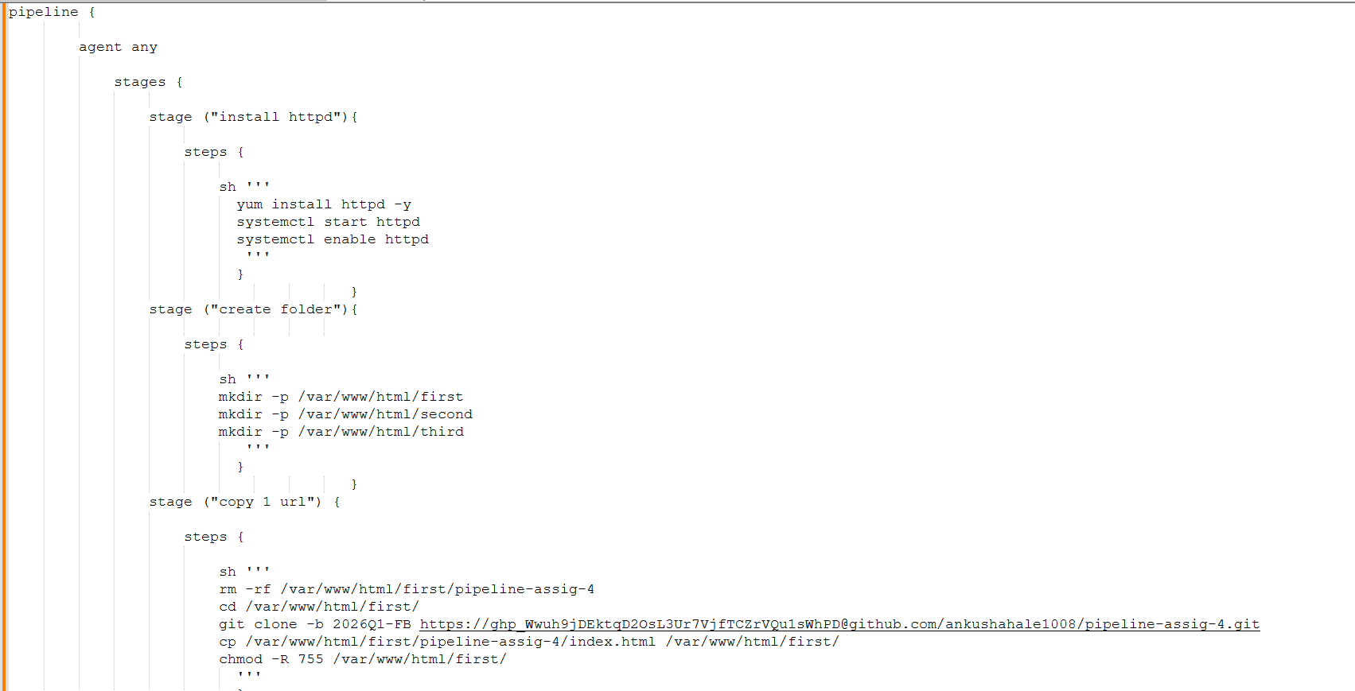
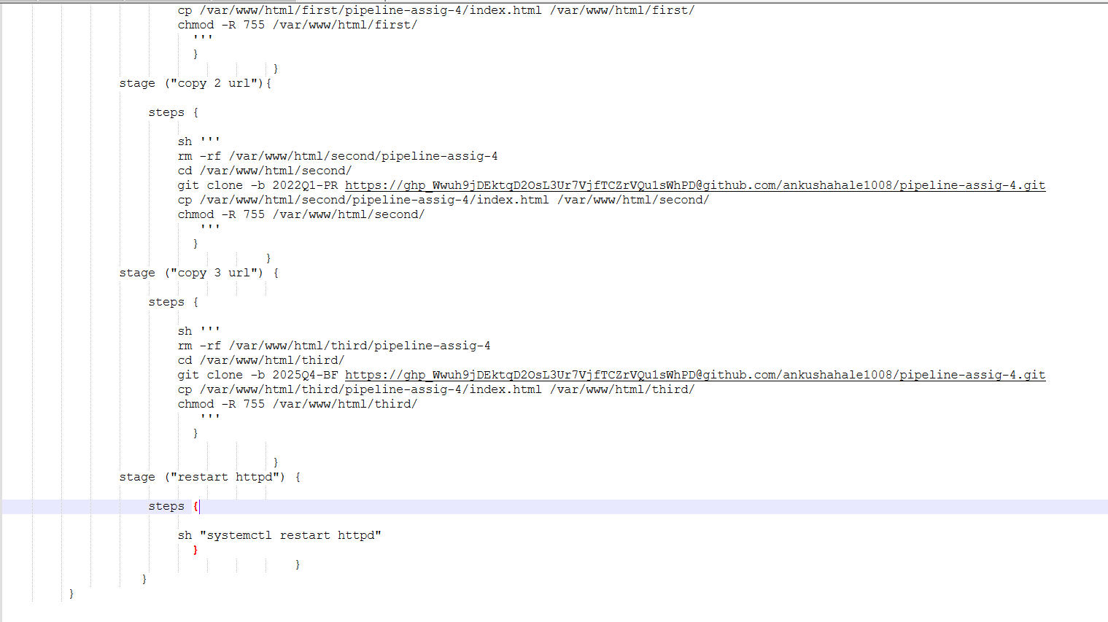
Step 6 – click on apply and save then build now after that check stages all working fine or not also check console output if any issue
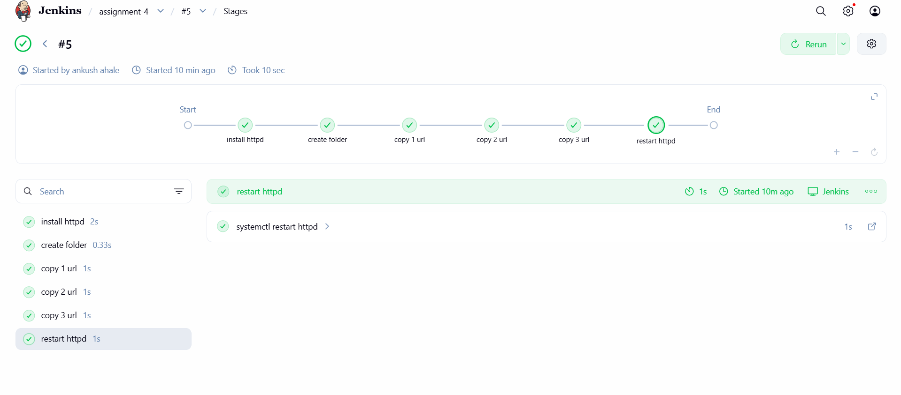
Step 7 – check output using url like http://ip/first, http://ip/second
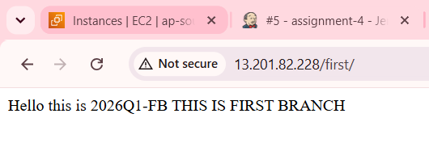
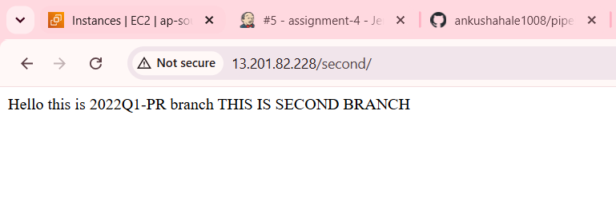
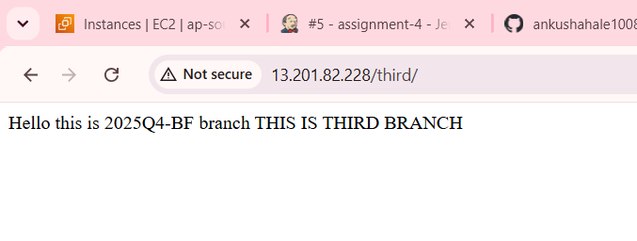
Assignment DONE successfully.

